### Professional

#### Botany

Canephora and Eugenioides are the parents of Arabica

There are over 120 species in the Coffea genus  
Approximately 55 of these are indigenous to Madagascar  
Other commercially grown species account for up to 1-2% of total global production

* Liberica & Excelsa

Review coffee’s origins

#### Varieties

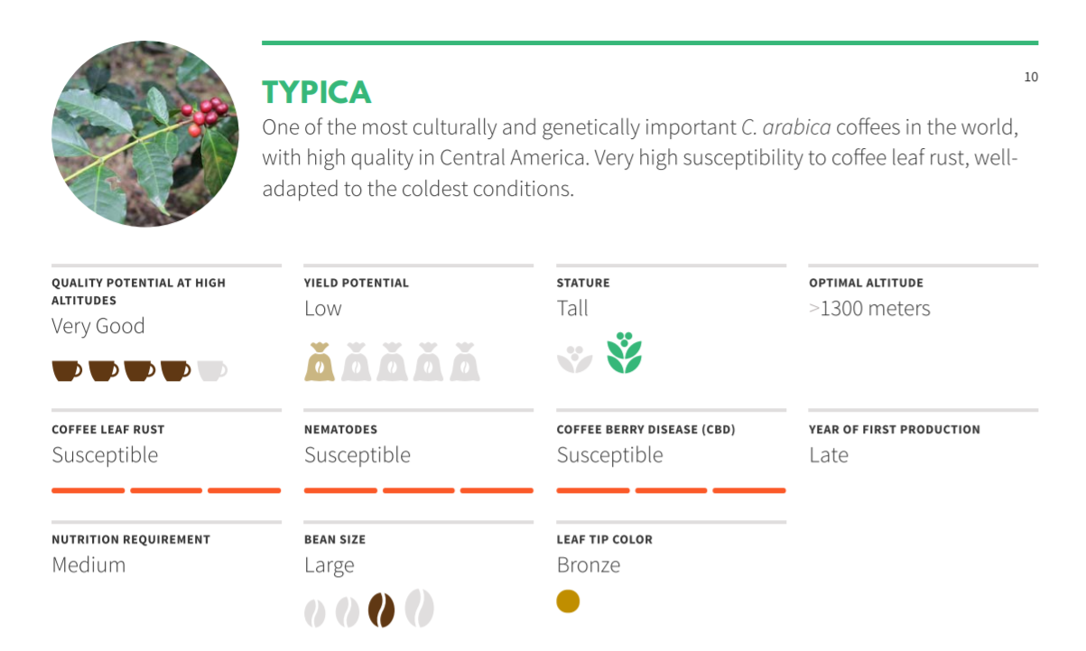

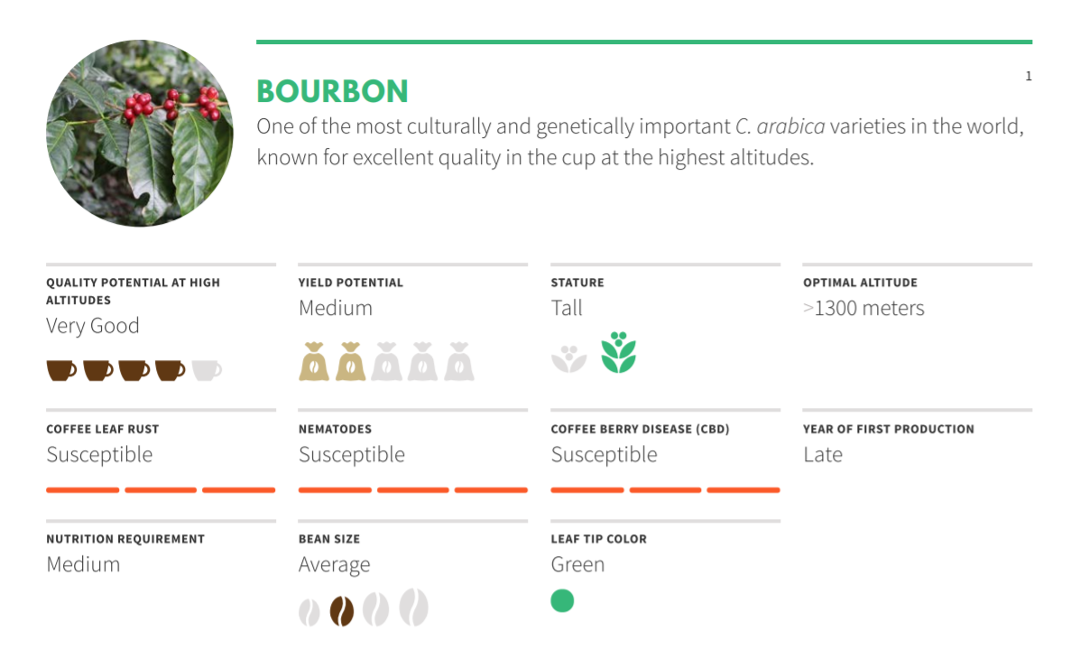

Cultivars have developed over the last 500 years as a result of specific selection  
A hybrid plant has both Arabica and Robusta genes, but is categorized as Arabica  
“Introgression” of genes is a long process

A catimor cultivar is a cross between Hybrid de Timor (a spontaneous mutation between  
Arabica and Robusta) and the Bourbon mutation Caturra, or has a parent cultivar that  
came from this cross

Arabica self pollinates

Robusta needs to be cross pollinated

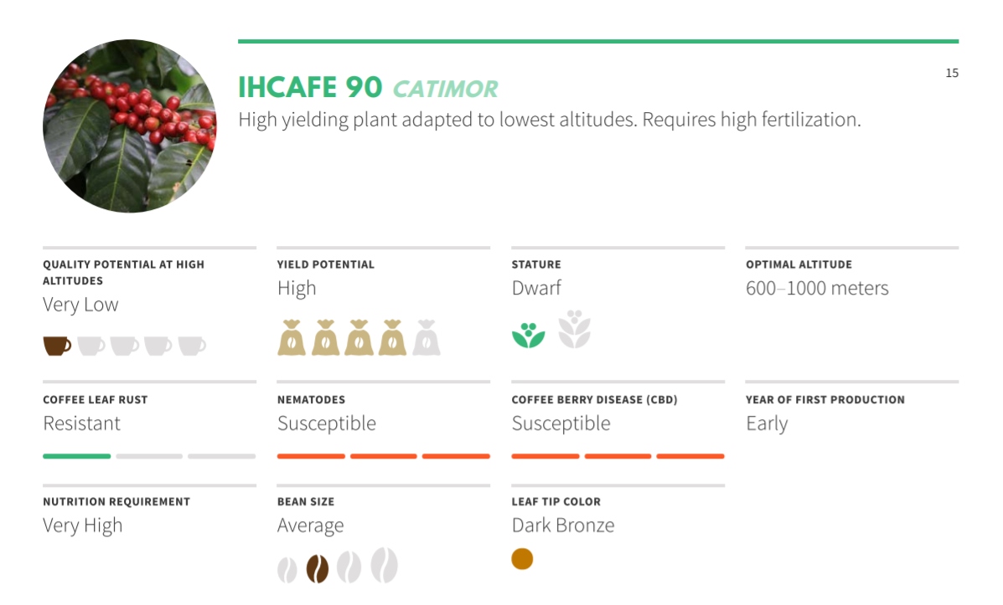

Plant breeding mainly focuses on disease resistance and increased yield  
Spontaneous mutation can cause a number of different ripe fruit colors

For example...yellow, orange, pink bourbon  
Shape characteristics vary, usually ranges from screen 14 through 20

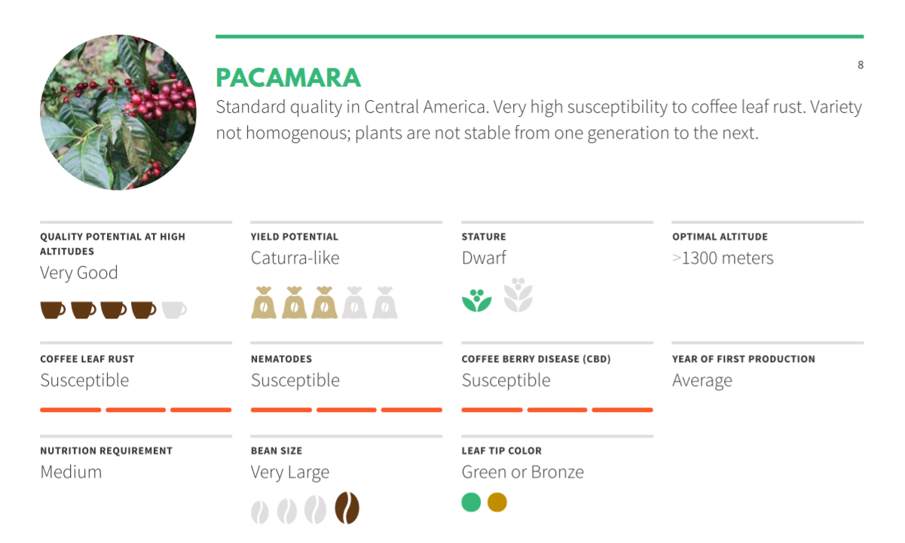

#### 

#### Growing Conditions

Rainfall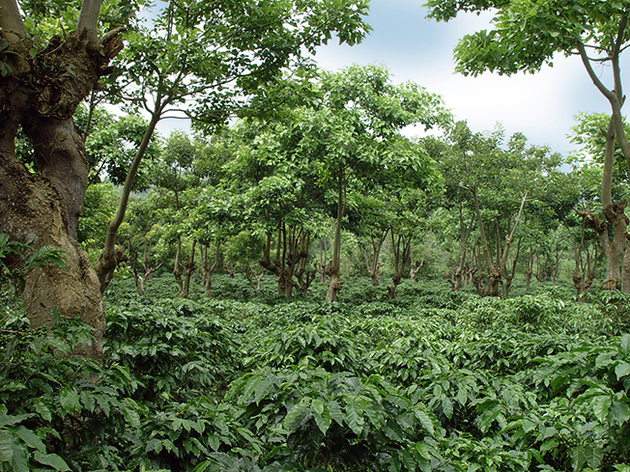

* 60 to 80 inches per year

Soil

* pH varies from acidic to neutral (~4-7)

Temperature Range

* 59° to 75° F
* Sensitive to cold / frost

Shade

* Cools temperature
* Helps with soil moisture and water control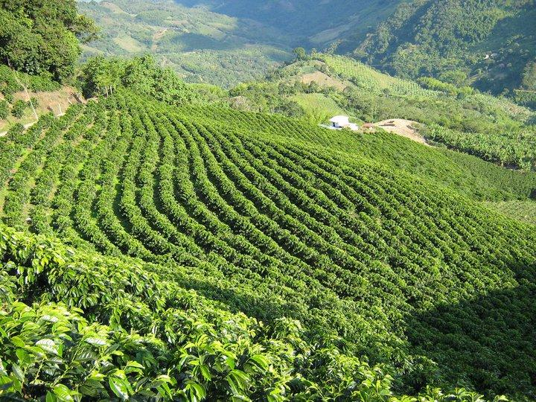
* Blocks wind

Sun

* Requires more nutrients/fertilizer
* Ripens more evenly

Altitude

* **Arabica 1000 to 2000+ masl**
* **Robusta 0 to 1000 masl**

Latitude

* Between the tropics of Cancer and Capricorn
* ~ 23° North and South of equator

Typically a one crop plant, but rains will lead to two crop cycles (main and fly)

Biennial in nature, has a large crop year followed by a vegetative year

#### World Production

ICO.org publishes reports and historical data

**Statistics will vary every year due to changes in consumption, prices, weather (drought/frost), natural disasters, plant diseases**

2017/18 crop year totaled 159,663,000 bags (60 kg)

#### Farming

70% of producers are smallholders  
Defined as producers with less than 10 hectares  
Typically run by the family  
Farms are larger and usually hire seasonal laborers to help with harvesting

Finca, Fazenda, Estate, Domaine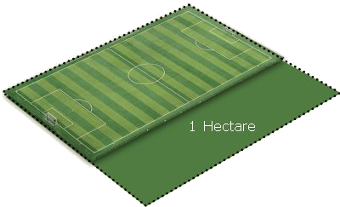

Cooperative, Beneficio

#### Plant Management

Fertilizers and pesticides are used to maintain productivity  
Pruning ensures productivity and quality  
Inputs are dictated by:  
 Economic cost  
 Certification  
 Local availability  
 Technical knowledge

Support from the government or cooperatives

#### Flower to Fruit

Depends on variety, weather, soil nutrients and inputs, maturity of the tree

#### Ripening

Arabica

* 6-8 months

Robusta

* 9-11 months

Liberica

* 1+ year

#### Seasonality

Every origin is different  
Typically starts at lower altitudes, meaning lower grown coffee ships first  
The best coffees from each region are available at different times of the year  
Usually in the drier winter seasons, depending on the hemisphere

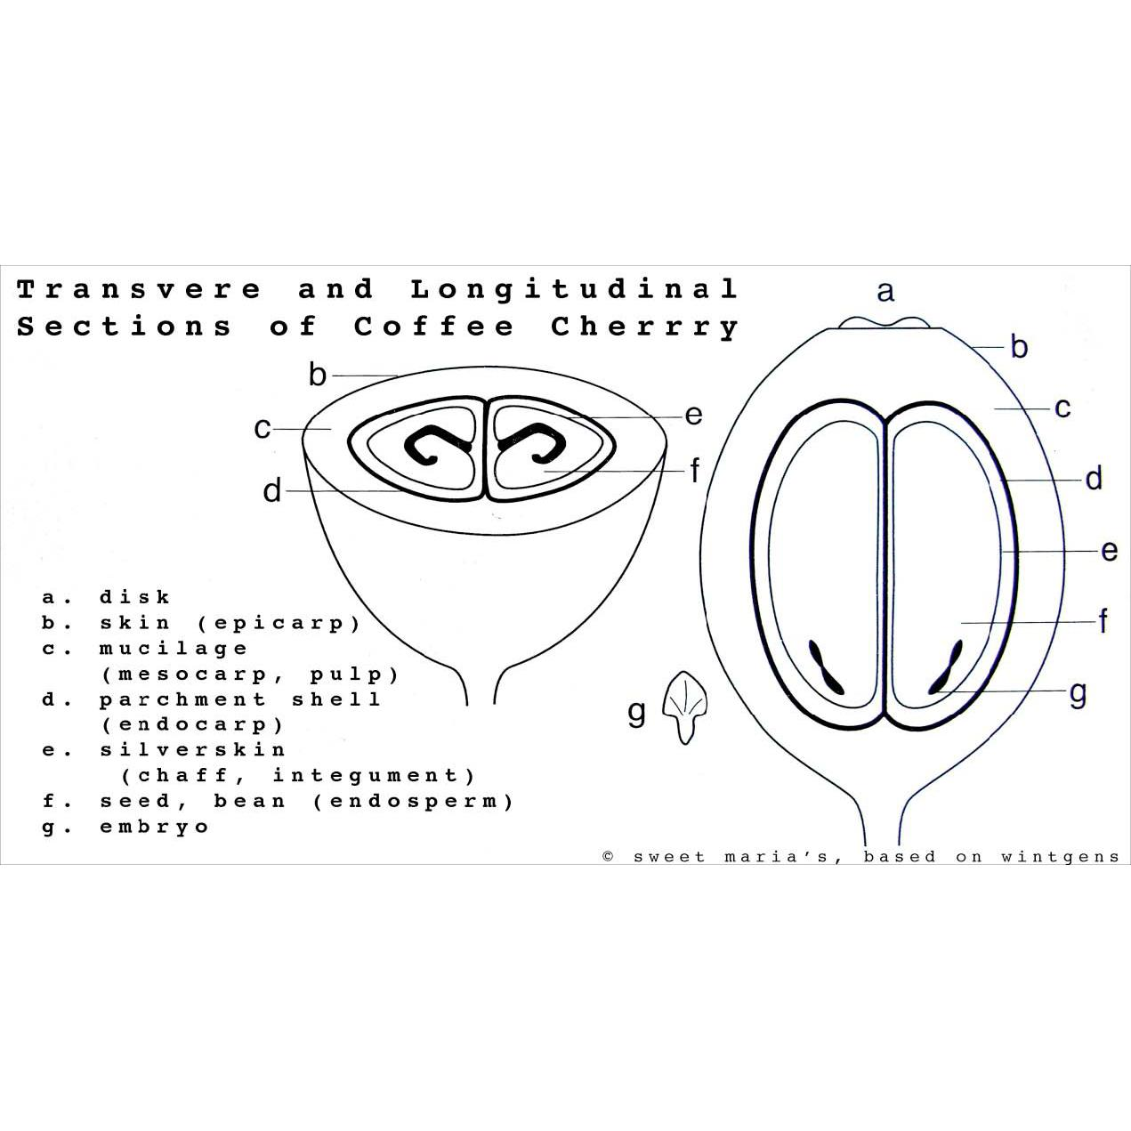

Weight Terms  
Only 18 - 20% coffee weight is the final green coffee we roast

|  |  |
| --- | --- |
| **State of Coffee** | **Kg per Kg of Green Coffee** |
| Fresh cherry | 5.56 |
| Dry cherry | 2.25 |
| Freshly pulped coffee | 3.39 |
| Washed and drained parchment | 2.31 |
| Dry parchment | 1.25 |
| Green coffee | 1.00 |
| Roasted coffee | 0.85 |

#### Picking

Review: strip, selective, mechanical

**Fully ripe coffee has a moisture content of 60 – 65%**  
Over ripe can have as little as 30 – 35%

Coffee is stripped at the end of the season to prevent disease

#### Washed Process

Flotation tank to sort/remove defective coffee, followed by pulping  
Channelling separates beans by density

**Fermentation removes the mucilage**

Concrete, tile, stainless steel tanks

Monitor time, temperature, pH, brix  
Newer term: “parchment dried”

**Colombia produces the most washed Arabica**

#### Natural Process

This is the most common process in the world  
Winnowing is tossing and removing debris  
More risk associated with unseen defects

Newer term: “fruit dried”

Brazil produces the most natural Arabica

#### Semi-Washed Process

Pulped and mucilage is left on the seeds prior to drying

Ecopulpers use little to no water   
Removing different amounts of mucilage changes cup characteristics  
Black, red, yellow, white honey

Newer term: “mucilage dried’

#### Wet-Hulled Process

Typically associated with Sumatra  
Traditional name is Giling Basah  
Parchment is removed at 25-35% moisture  
Newer term: “seed dried”

#### Monsoon Malabar

Specific to India  
Coffee is left out during heavy rains  
Leads to large white-ish yellow beans

#### Drying

**For washed or semi-washed, a depth of 2.5 cm is ideal for parchment on raised beds**  
For naturals, depth is 4 to 6 cm of whole cherry  
If above these levels, the risk for mold and earthy/musty flavors increases

Drying must be on impervious material to prevent the risk of Ochratoxin A (OTA)  
Raking is necessary to obtain defect free coffee  
Coffee may be covered in case of rain or excessive humidity  
**Target moisture content is 12%**

#### Ochratoxin A

A mycotoxin found in green coffee produced by species of fungi  
Occurs in coffee as a result of poor hygiene and quality control in post-harvest processing  
Chris Kornman at Royal has written great articles on the topic

#### Resting

Coffee rests in parchment for minimum of 30 days and sometimes up to 120 days  
**Allows moisture level to stabilize  
Results in an improved cup, less astringent**

Held in silos, supersacks or grainpro bags

#### Dry Mill

Remove parchment, sort by size

**Gravity separators (Oliver tables) sort by density**

Hand sorting and optical sorting

#### Grading

Different countries have different systems  
AA, AB, Excelso, Supremo, Scr 15+, Scr 17-18  
PW, HG/HB, SHG/SHB  
EP, Gr 1, Gr 2

#### Defects

Found in SCA Green Grading Handbook

Primary and Secondary categories

Damage can occur in the field, process, or storage

**Sample weight is 350g**

#### Quakers

Appear much lighter than the rest of the roast  
If there are many quakers, the roast is “motley” or not uniform  
Tastes like peanut skin, unpleasant or drying nutty flavor

#### SPOT

Buy from a trader/importer  
XWH or FOT, already in a US warehouse  
Can be delivered immediately  
Usually SAS (Subject to Approval of Sample)

#### Futures

“C” market level +/- differential  
Premium or discount based on origin and quality  
Barchart.com

#### Arbitrage

**The price difference between the New York and London markets when compared in the same unit of weight**  
Arabica is usc/lb  
Robusta is USD/MT

#### Hedging

Financial tool for risk management  
“trading operation that enables management of the risks posed by unforeseen price movements”

#### GCA Contracts

Green Coffee Association terms & conditions  
Outlines quantity, quality, location, price, payment terms, delivery period

Price to be fixed or outright  
Signed by buyer and seller

#### Shipping

FOB

CIF  
FOT  
XWH  
**Bill of Lading (like a title of ownership)**  
Weight Note

#### Bags

|  |  |
| --- | --- |
| **Region** | **Weight** |
| Mexico & Central America | 69 kg |
| Brazil | 59 or 60 kg |
| Colombia | 70 kg |
| Africa & Asia | 60 kg |

**Sometimes India and others in 50vkg bags**

**Microlots sometimes 30 kg or 15 kg**

Burlap / Jute  
Grainpro / Ecotact  
Vacpacs + box

#### ICO Marks

11 digits

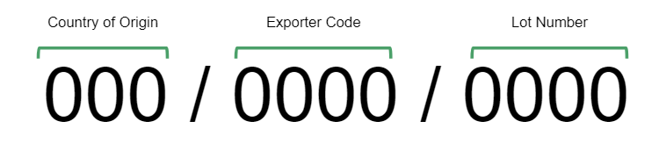

#### Moisture

Condensation can build up during shipment   
Containers must be sealed properly  
Containers can be lined with kraft paper or silica packs

#### Storage

Humidity range 55-65%

Temperature range 40-70°F

#### Quality

Roasters and importers have a “time bar” for placing quality claims  
Must evaluate appearance and cup of arrival sample ASAP  
Notify the shipper immediately if there is an issue  
Usually within 10 days of landing

#### Certifications

Rainforest Alliance

* Recently merged with UTZ
* **biodiversity, conservation and community development**
* **workers’ rights and productive agricultural practices**
* **comprehensive sustainable farm management**

Fair Trade

* Two organizations: FT USA and FLO
* fair prices and direct trade
* community development and environmental stewardship

Organic

* ecological processes
* biodiversity and cycles adapted to local conditions
* avoid agrochemical inputs

#### Decaffeination

MC / DCM

* **Methylene chloride / Dichloromethane**
* Has shortest treatment time

EA

* **Ethyl acetate**
* Solvent can be derived from fermented sugar cane

**CO2**

**Water**

(Both CO2 and Water processes can be sold as organic)

#### Lab Requirements

Non-reflective, neutral counter  
Lighting for green grading  
Red and black light

#### Sizing Screens

Used to determine if a sample meets the contract specification  
Up to 10% under is accepted

#### Moisture Meters

Portable, for use in the field or limited space

Larger models have more functions, can also measure density

Different machines have different tolerances and need to be calibrated